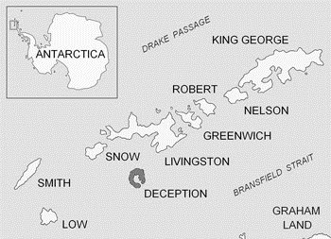
Deception Island Antarctica

- From what direction would the wind be coming from to blow straight through Neptune’s Bellows? ______________________
- Put Goddard Hill, Mt. Pond and Mt. Kirkwood in order of height
Highest ___________________________________
Mid ______________________________________
Lowest ___________________________________
- Which peak is the furthest North? _____________________
- Which peak is the least steep? ________________________
- Which peak is the most steep? ________________________
- How do you know? _________________________________
- Approx. how wide is Whalers Bay? _____________________
- Why is Whalers Bay such a calm harbour even though it is close to Neptune’s Bellows? __________________________
__________________________________________________________________________________________________
- Approx. how far would you have to go to sail entirely around Deception Island? ______________________
- What is the name of the first island due north of Deception Island? __________________________________________
- Imagine you are standing on Mt. Pond, describe the landscape around you, use these words in your description.
steep open-sea sheltered-harbour ice(!)

Answers - Deception Island Antarctica

- South East – 1 mark
- Mt. Pond, Mt Kirkwood, Goddard Hill – 2 marks all, 1 mark 1
- Goddard Hill – 1 mark
- Goddard Hill – 1 mark
- Mt. Kirkwood – 1 mark
- Closeness of contour lines – 1 mark
- 1km – 1 mark
- No direct wind or waves through Bellows to the Bay – 1 mark
- 65 ± 20km – 1 mark
- Livingston Island – 1 mark
- One direction can see sheltered harbour – 1 mark;
Open sea in the opposite direction – 1 mark;
Also see open sea all around – 1 mark;
Very steep slope around the mountain standing on – 1 mark; Can see down the slope to old whaling station – 1 mark;
See ring of mountains/hills surrounding the harbour – 1 mark;
See across the sea to the other islands in the group – 1 mark.
½ mark for appropriately using each of given words.
Other relevant non-repeated observations – 1 bonus mark each.

Total, 1-10 = 11 marks
Q.11 = 9 marks + any bonus.
