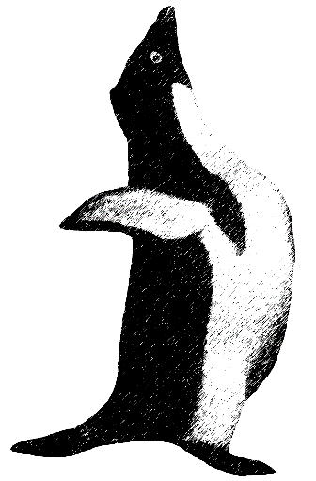
Antarctica Project Penguin Plan
Tick off the points as you complete them
Your report on Antarctica should cover:
- What is Antarctica like?
- How is Antarctica used by people?
- What are the effects of these uses on the ecosystem?
- How can these pressures be managed?
- What are the aims of the Antarctic Treaty?
- What do different group of people think about the way Antarctica is managed?
- What do you think?

Further details:
What is Antarctica like?
- Describe the location of Antarctica.
- What are the key features of Antarctica?
- How big is the continent?
- What is the landscape like? What else lives there?
- What is the climate like?
- Why is the climate like this?
How is Antarctica used by people?
Whaling and fishing - Scientists - Mining - The hole in the Ozone layer - Territorial claims - Tourism - Global Warming.
How can the pressures on Antarctica be managed?
- The Antarctic Treaty.
- What are the different viewpoints about Antarctica and the way it should be used?
- Different people have different views

